Data Analytics Mini Project
- Original Dataset Source link:
E-Commerce Sales

- Cleaned Dataset Link:
https://docs.google.com/spreadsheets/d/1E-ziML_jbsAXG6B7y3xasC7xj-yQ0kNh/edit?usp=sharing&ouid=114220340229278978270&rtpof=true&sd=true

3. PowerBI Dashboard link:
https://drive.google.com/file/d/13uMzY9LBbOeUg8wN_FCg42ltqXsefmfm/view?usp=drive_link

📊 Ecommerce Sales Data Analysis and insights using Excel and Power BI
🏷️ Project Overview
- Domain: Ecommerce – Profit & Revenue Analysis
- Business Context: Finance
🛠️ Tech Stack
- Tools: Power BI, Microsoft Excel
- Language: DAX (Data Analysis Expressions)
- Technologies: Power Query, Data Modeling
📊 Key Focus
- Financial data analysis and reporting
- Profitability and revenue insights
- Interactive dashboard development using Power BI
🧹 Data Pre-processing (Excel)
Data Cleaning
- Verified dataset integrity and confirmed absence of duplicate records.
- Standardized textual inconsistencies in Customer Name, Product Name, and Sub-Category using:
  - Find & Replace
  - TRIM() for whitespace removal
  - PROPER() for consistent capitalization

Missing Value Treatment
Categorical Variables
- Addressed null values in Sub-Category and Payment Mode using conditional imputation:
  - Replaced missing entries with "Unknown" and "Cash" respectively using IF(ISBLANK()).
Numerical Variables
- Quantity:
  - Imputed using conditional mean (AVERAGEIF()) based on relevant criteria
  - Standardized values using ROUND()
- Unit Price:
  - Derived missing values using a business rule:
  - Unit Price = Total Amount / (Quantity × (1 - Discount))

Feature Engineering
- Extracted Order Month and Order Year from the Order Date column to enable time-series analysis.

Data Structuring & Validation
- Sorted dataset by Order ID in ascending order.
- Applied filtering techniques to validate cleaned data and ensure consistency.

Statistical Analysis
- Leveraged Excel’s Data Analysis ToolPak to compute:
  - Sum, Mean, Median, Mode, Skewness
- Applied across key variables:
  - Quantity, Unit Price, Discount, Sales, Profit

📂 Dataset Attributes
This dataset contains summarized eCommerce sales metrics used for financial analysis and dashboard reporting.
🧾 Columns Description
Column Name | Description
Quantity | Number of units sold
Unit Price | Price per unit of product
Discount | Discount applied on products
Sales | Total sales value generated
Profit | Profit earned after discount and cost adjustments
📊 Statistical Metrics Included
Metric | Description
Mean | Average value of each metric
Median | Middle value of the dataset
Mode | Most frequently occurring value
Standard Error | Measure of data variability
📈 Usage in Project
Area | Details
Analysis | Financial performance analysis
Insights | Sales trends and profitability evaluation
Power BI | Used for DAX measures and KPI creation
🧹 Data Characteristics
Feature | Description
Data Type | Pre-aggregated dataset
Structure | Organized for analysis and visualization
Purpose | Dashboarding and insights generation

📊 GitHub Project: Ecommerce Sales Data Analysis Dashboard (Power BI)
📌 Project Overview
This project involves analyzing eCommerce sales data using Power BI, leveraging measures and DAX calculations to derive meaningful insights through interactive dashboards and visualizations.
The dashboard provides a comprehensive view of key business metrics such as:
- Total Orders
- Total Sales
- Total Profit
- Total Revenue
- Total Discount
- Year-to-Date (YTD) performance

📊 Dashboard Features
🔹 Key Visualizations
- Clustered Bar Chart → Total Orders by Category and Region
- Donut Chart → Profit distribution by Category
- Stacked Area Chart → Monthly trend of Total Sales and Profit
- Tree Map → Total Sales by City, Region, and Quantity
- Line & Stacked Column Chart → Revenue and Sales comparison by Month
- Funnel Chart → Total Discount by Category

🎯 Interactive Capabilities
- Dynamic filters and slicers
- Drill-down functionality in Tree Map
- Clean and user-friendly layout
- Well-defined titles, legends, and labels

📤 Output
- Final dashboard exported as PDF
- Interactive .pbix file included for customization

📈 Summary Analysis
🔍 Key Insights
- Sales & Revenue Trends Monthly analysis shows fluctuations with peak sales periods indicating seasonal demand patterns.
- Profitability by Category Certain categories contribute significantly more profit, while others show lower margins despite high sales.
- Regional Performance Orders and sales vary across regions, highlighting top-performing markets and areas needing improvement.
- Discount Impact High discounts in some categories do not always translate into higher profits, indicating potential margin loss.
- City-Level Contribution Tree map reveals a few cities dominating total sales, suggesting strong localized demand.

💡 Business Recommendations
- Focus on high-profit categories for growth
- Optimize discount strategies to protect margins
- Strengthen marketing in underperforming regions
- Leverage seasonal trends for inventory planning

🚀 How to Use Download the .pbix file Open in Power BI Desktop Explore dashboard using slicers and filters
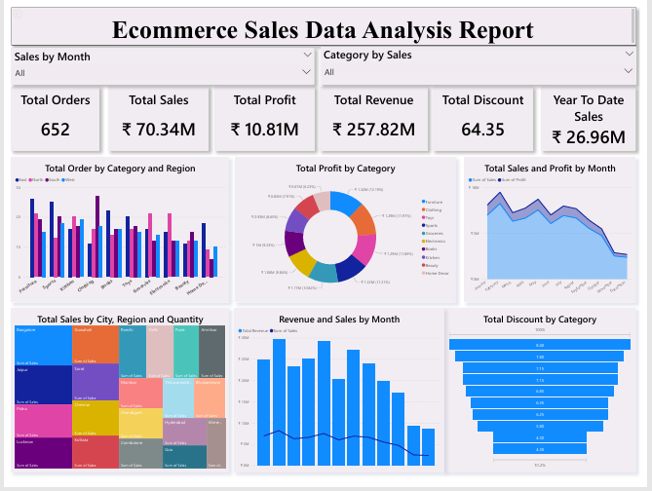
- Data Pre-processing using Excel
- Data Cleaning:
- The dataset contained no duplicates, but some inconsistencies were identified in CustomerName, Product Name and Sub-Category.
- Using the Find and Replace function those inconsistencies are corrected.
- Using TRIM() & PROPER() functions to remove extra spaces and capitalize the first letter of each word.
- Data Imputation:
- Find some data are missing in Sub-Category and Payment Mode
and imputed by the formula
=IF(ISBLANK(cell),"Unknown",cell)
=IF(ISBLANK(cell),"Cash",cell)
- Now the missing values are replaced with “Unknown”.
- Numerical columns such as Quantity and
Unit Price had missing values. These were imputed using:
for Quantity used
=IF(ISBLANK(cell),AVERAGEIF(range,criteria,average_range),cell)
and rounded up the values by =ROUND(N,0)
and for Unit Price used
=IF(ISBLANK(Unit_Price), Total_Amount / (Qty*(1-Discount)), Unit_Price)

- From the Order Date, Order Month and Order year were extracted through the Delimiter
- Using Filtering and Sorting ascending the Order ID column
- The Data Analysis ToolPak was used to calculate descriptive statistics such as sum, average, median, mode, and skewness for Quantity, Unit Price, Discount, Sales and Profit.

- Data Visualization using Power BI
- Build a report/dashboard with
- Multiple visualizations that communicate insights clearly for the Measure of Total Orders, Total Sales, Total Profit, Total Revenue, Total Discount and Year to Date
- Used cluster bar chart for Total order bt Category and Region
- Used Donut chart for Profit by Category
- Used Stacked Area chart for Total Sales and Profit by Month
- Tree chart for Total Sales by City, Region and Quantity
- Line and stacked column chart for Revenue and Sales by Month
- Funnel chart for Total Discount by Category
- Clear and interactive layout using filters, slicers, drill-downs on Tree chart
- With Proper titles, labels, and legends and final Dashboard was created with the name of Ecommerce Sales Data Analysis Dashboard and export as PDF

